Results

We first assessed overall yield performance and performance gains by each race across the study period. In agreement with previous studies, each race had a different expected yield by 2015 (F_{2,13170} = 608; p < 0.001, Figure 2a; Table S1): Andean were expected to yield 2370 ± 40 kg ha⁻¹, Durango lines, 3060 ± 30 kg ha⁻¹, and Mesoamerican lines, 2850 ± 40 kg ha⁻¹. All races’ yields improved during the study period, albeit at different rates (F_{2,13170} = 4.00, p = 0.02). Andean yields grew by 16 ± 2 kg ha⁻¹ (p < 0.001), Durango yields grew by 14 ± 1 kg ha⁻¹ (p < 0.001). Mesoamerican yields grew the fastest, by 20 ± 2 kg ha⁻¹ (p < 0.001).

To tested whether these yield gains were achieved without, by utilizing, or at a cost to local adaptation, we assessed the strength of local adaptation in each of the major races of dry bean. Local adaptation was indicated by the home field advantage. In Andean lines, HFA accounted for 1.1% of yield variation, and reduced unexplained yield variation by 6.4 percentage points (Table 2). In Durango lines, HFA accounted for 1.3% of yield variation and reduced residual variation by 8.3 percentage points. Similarly, HFA accounted for 1.3% of Mesoamerican yield variation, and reduced residual variation by 7.7% percentage points. None of the races’ home field advantages were tempered by genetic relatedness, as linear models where HFA interacted with first three principle components (PCs) of respective kinship matrices were less parsimonious (ΔAIC = -339 (Andean), -890 (Durango), and -608 (Jalisco); TABLE S2). These three PCs accounted for 39%, 44%, and 42% of genetic variance in the Andean, Durango, and Mesoamerican lines, respectively (Figure S2).

Local adaptation was both agronomically significant and, contrary to our hypothesis, often larger than expected by chance. Andean lines were the exception, and received no larger yield gain than the expected 357 kg ha⁻¹ based on variation in Andean yields (p = 0.21; Figure 2b). In Durango lines, HFA conferred a yield gain of 472 kg ha⁻¹, 109 kg ha⁻¹ larger than expected (5%: 72 kg ha⁻¹; 95%: 146 kg ha⁻¹ ; p = 0.002). Durango HFA was 15% of expected 2015 yields, and worth 34 years of average yield gains. In Mesoamerican lines, HFA conferred a yield gain of 453 kg ha⁻¹, 89 kg ha⁻¹ larger than expected (5%: 44 kg ha⁻¹; 95%: 134 kg ha⁻¹; p = 0.002). Mesoamerican HFA was 16% of expected 2015 yields and worth 22 years of average yield gains.

That home field advantage was often larger than expected by chance indicates that dry bean breeding has preserved some environmental specialization in the Durango and Mesoamerican lines. However, we found inconsistent evidence that breeding tried to leverage HFA based on based on changes in HFA among races (F_{2,94} = 4.82; p = 0.01; Table S3). HFA increased slightly across the study period in Durango lines, by 4.3 ± 2.0 kg ha⁻¹ yr⁻¹ (p = 0.04; Figure 2b). In Mesoamerican lines, however, HFA decreased by 8.4 ± 3.5 kg ha⁻¹ yr⁻¹ (p = 0.02), ultimately becoming indistinguishable from the expected HFA based on variation.

With home field advantage’s potential established in bean, we the used heritability of yield to indicate regions in which breeding for narrow environments might be most feasible. As hypothesized, yield heritability was highly variable across the study region, ranging from ### in the northwest and decreasing in a south-easterly direction to ### (Figure 3). Yield heritability also varied across time, depending on the race (p = ###). As hypothesized, heritability decreased in Mesoamerican lines by #### points/year (p = ###), suggesting a homogenization in yield potential. Yet in contrast with expectations, among Andean and Durango varieties, yield heritability increased by ### points/year (p = ###). In Durango lines, which did not see a difference in HFA, the increase in yield heritability indicated greater variation yield potential among varieties in later years (Table 1). In Andean lines, however, the increase in both HFA and yield heritability suggests increasing adaptation to local conditions.

Efficiently breeding for environmental specialization requires high yield gains from specialization, and high heritability in yields. We found that those sites with high heritability also tended to confer higher home field advantages to compatible lines (R² = ###; p = ####; Figure 4a). Moreover, environmental specialization must have a predictable genetic basis. In support of this requirement, varieties that were more closely related also had home sites that were closer in the Durango (Mantel’s r = 0.11; p = 0.001) and Mesoamerican (Mantel’s r = 0.068; p = 0.01) races, but not within the Andean race (p = 0.6; Figure 4b).

Overall, the low-yielding Andean race saw modest improvements in yield across the study period and showed little evidence of local adaptation. The high-yielding Durango race also saw modest improvements in yield across the study period, which coincided with a modest increase in local adaptation. Finally, the genetically diverse Mesoamerican race the most dramatic improvements in yield across the study period, at the expense of local adaptation. In Durango and Mesoamerican lines, local adaptation conferred agronomically significant yield gains that were equivalent to decades worth of background yield improvements.

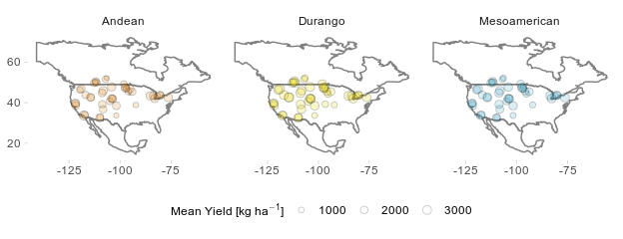
Figure 1: Locations and mean yields at sites within the CDBN variety trials. Only sites used at least three years are shown.

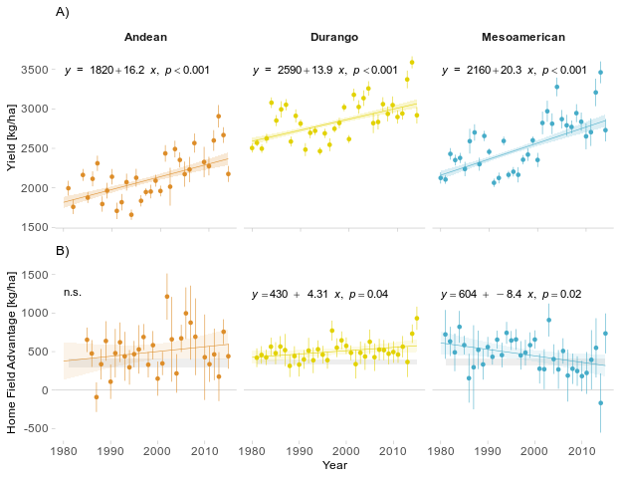

Figure 2: Trends in A) yield and B) home field advantage across the study period by race. In B), the gray bar indicates the 90% confidence interval of the expected home field advantage based on permutation. Error bars are standard errors. Shading around regression lines indicate 95% confidence intervals. n.s.: not significant at p < 0.05.

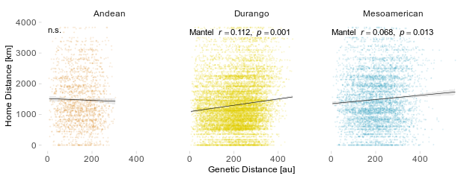

Figure 4: Mantel’s correlation between genetic distance and the distance of home sites for lines within the Andean, Durango, and Mesoamerican races. Genetic distance is based on the first three principal components of a linkage-corrected kinship matrix (Figure S2). Shading around regression lines indicate 95% confidence intervals. n.s.: not significant at p < 0.05.

Table 2

Table 2
Partitioning of CDBN Yield Variances
 | Race
 | Andean | Durango | Mesoamerican
Home Site | 1.1% | 1.3% | 1.3%
Residuals | 15.6% | 14.1% | 15.8%
Genotype | 3.2% | 3.3% | 4.1%
Site | 29.0% | 33.1% | 30.9%
Year | 2.5% | 2.4% | 3.0%
Site-Year | 48.7% | 45.7% | 44.9%
Residual Reduction¹ | 6.3% | 8.3% | 7.7%
¹ Proportion of residual variance explained by home site

Table S1
Table S1
ANOVA of Yield Across Time
 | Sum Sq | Df | F value | Pr(>F)
Year | 252,500,000 | 1 | 292.70 | 0.000
Race | 1,050,000,000 | 2 | 608.26 | 0.000
Year*Race | 6,895,000 | 2 | 4.00 | 0.018
Residuals | 11,370,000,000 | 13174 | - | -

Table S2

Table S2
AIC1 of Competing Home Field Advantage Models
 | Andean | Durango | Mesoamerican
With Home Field | 3434 | 6772 | 5095
Variety, Site, Year | 3599 | 7323 | 5421
With Home Field, Kinship | 3773 | 7662 | 5703
With Kinship | 3926 | 8143 | 5997
1Akaike Information Criterion

Table S3

Table S3
ANOVA of Home Field Advantage Across Time
 | Sum Sq | Df | F value | Pr(>F)
Year | 4.755 | 1 | 0.00 | 0.992
Race | 36,290 | 2 | 0.43 | 0.654
Year * Race | 410,000 | 2 | 4.82 | 0.010
Residuals | 3,994,000 | 94 | - | -

Figures and Tables

FIGURES
- Mean yield | race at each location (expected, last year of study, based on trends)
- Yield and HFA
  - Yield trend by race
  - HFA trend by race, with permutation means (or medians each year?)
- Heritability
  - Heritability by locations (by race?)
  - Heritability across time by race
- HFA and Breeding
  - HFA ~ Heritability
  - Home location ~ Genetic Location.

SUPPLEMENTARY FIGURES
- Heritability ~ Variance
- PCs and scree plots

TABLES
- Interpretation of heritability combined with HFA (increases, no change, decreases across time)
- HFA variance explained

SUPPLEMENTARY TABLES
- ANOVA yields by year (year zero = present for ease of getting effects)
- SUPPL - HFA model AIC
- HFA ~ Time | Variety

